Design and Implementation of an Arduino-Based Line-Following Robot with Ultrasonic Obstacle Avoidance
Ibrahim
Hochschule Hamm-Lippstadt (HSHL) · Prototyping Module
June 2026

Abstract—This paper presents the design, implementation, and empirical evaluation of an autonomous mobile robot built for a university prototyping module. The robot uses an Arduino Uno to combine infrared (IR) line tracking with ultrasonic obstacle avoidance on a differential-drive chassis, under the constraint that only the components supplied in a fixed project kit may be used. A reactive, priority-ordered control loop performs obstacle detection, stop-line detection, and line following; obstacles are circumnavigated with a three-phase “V-dogleg” maneuver that returns to the line through closed-loop re-acquisition on the right IR sensor. Because the dominant behaviours of the matched kit — motor static friction, a pulse-width-modulation (PWM) dead-zone, and surface-dependent turning radii — are poorly represented by idealised simulation, the system was validated through an iterative hardware-in-the-loop methodology, yielding reliable line tracking, repeatable obstacle avoidance, and dependable stop-line halting. The paper also documents two empirical findings contrary to initial intuition: geared DC motors require a brief high-PWM kick-start to break static friction, and a wider PWM gap between the wheels yields a tighter — not wider — turning arc.
Index Terms—Arduino Uno, autonomous mobile robot, line following, obstacle avoidance, differential drive, PWM motor control, L298N, infrared sensor, ultrasonic ranging, embedded systems.
1. Introduction and Objectives
Autonomous line-following robots are a classic platform for teaching embedded control, because they integrate real-time sensing, decision logic, and actuation within tight resource limits. This project, carried out for the prototyping module at Hochschule Hamm-Lippstadt (HSHL), required the design of a small robot car that autonomously follows a marked track, halts at stop lines, and avoids obstacles placed in its path. A single constraint shaped every design decision: only the parts supplied in the project kit could be used, and no additional hardware — for example external voltage regulators or alternative batteries — was permitted.
The specific objectives were:
- Track a continuous line reliably along straight and curved sections of the test track.
- Detect and circumnavigate an obstacle placed on the line, then resume tracking automatically.
- Detect stop lines and bring the robot to a controlled halt.
- Accomplish all of the above using only components supplied in the project kit.
- Produce documentation, diagrams, and source code suitable for assessment and public release.
The remainder of the paper describes the system architecture and engineering methodology (Section 2), the hardware and software implementation (Section 3), the testing approach and results (Section 4), the principal challenges and their solutions (Section 5), and conclusions with proposed future work (Section 6).
2. System Design and Engineering Approach
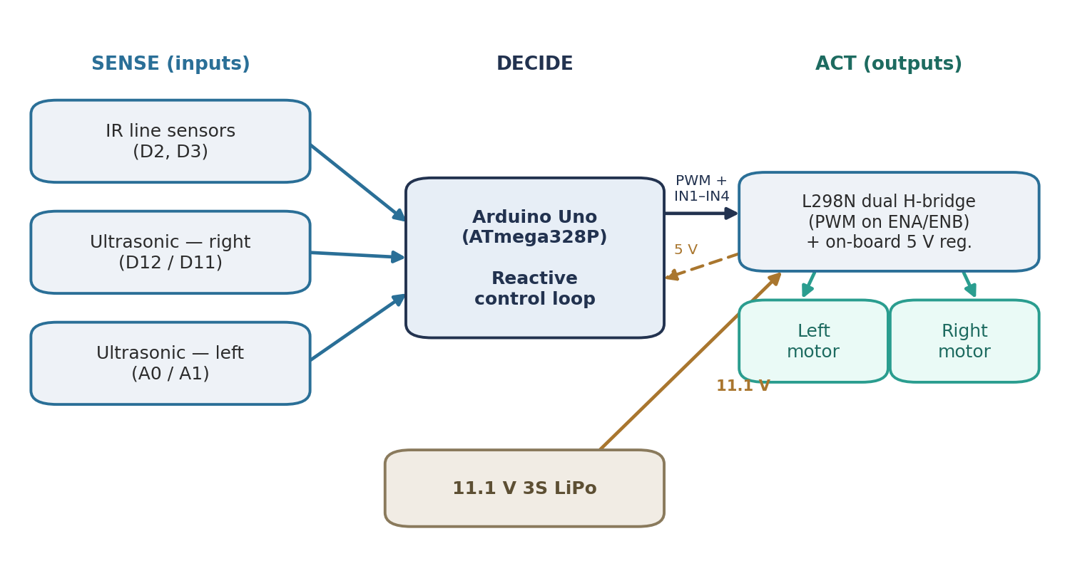
Figure 1. System architecture. The robot follows a sense–decide–act loop: the IR and ultrasonic sensors feed the Arduino, which drives the two motors through the L298N. The driver’s on-board regulator returns a stable 5 V to the Arduino from the 11.1 V LiPo.
The robot follows the classic sense–decide–act paradigm shown in Fig. 1. Two downward-facing IR reflectance sensors detect the line, two HC-SR04 ultrasonic sensors detect obstacles ahead, an Arduino Uno executes the control logic, and an L298N dual H-bridge drives two geared DC motors on a differential-drive (skid-steer) chassis. Steering is achieved purely by varying the relative speed and direction of the two wheels; no steering servo is used. A single 11.1 V three-cell lithium-polymer (LiPo) battery powers the motors through the L298N, whose on-board regulator supplies a stable 5 V to the Arduino.
The control strategy is deliberately reactive rather than model-based. Instead of estimating a position on a global map, the robot responds directly to the current sensor state on every loop iteration. This keeps the software simple, deterministic, and fast enough to run comfortably on the Uno’s 16 MHz microcontroller, and it suits a task in which the relevant environment — a line and the occasional obstacle — is fully observable from the on-board sensors.
The engineering methodology was iterative and empirical. Rather than rely on idealised simulation, development proceeded in a tight loop: a change was made to the sketch, the robot was run on the physical track, the observed behaviour was recorded with the aid of serial telemetry, and the next adjustment was derived from that observation. This hardware-in-the-loop approach was chosen because the effects that ultimately governed the robot — motor static friction, the PWM dead-zone, wheel slip, and the reflectivity of the actual test surface — are precisely those that simplified circuit or kinematic simulators omit. As Section 5 documents, physical testing repeatedly corrected assumptions that had appeared sound on paper.
3. Hardware and Software Implementation
3.1 Hardware architecture and wiring
The complete pin assignment is listed in Table 1. The two IR sensors are mounted close together at the front of the chassis and report a digital high or low according to whether they see the dark line or the light floor. The two ultrasonic sensors face forward to measure the distance to obstacles. The L298N receives four direction signals (IN1–IN4) and two PWM enable signals (ENA, ENB) from the Arduino.
A critical implementation detail concerns the L298N enable pins. The driver ships with jumpers that tie ENA and ENB high, forcing the motors to full speed. These jumpers were removed so that ENA and ENB could instead be driven with PWM from pins D5 and D10 — which is what makes proportional speed control, and therefore controlled cruising and turning, possible at all.
Table 1. Pin assignment and wiring.
Function | Arduino pin(s) | Notes
Motor A — speed (PWM) | D5 (ENA) | enable jumper removed *
Motor A — direction | D6, D7 (IN1, IN2) | H-bridge inputs
Motor B — direction | D8, D9 (IN3, IN4) | H-bridge inputs
Motor B — speed (PWM) | D10 (ENB) | enable jumper removed *
Left IR line sensor | D2 | digital line detect
Right IR line sensor | D3 | digital line detect
Right ultrasonic (HC-SR04) | D12 / D11 | trigger / echo
Left ultrasonic (HC-SR04) | A0 / A1 | trigger / echo
* The L298N enable jumpers are removed so that ENA/ENB accept PWM speed control (see §3.1).
3.2 Power architecture
Power flows from the 11.1 V LiPo into the L298N motor supply; the L298N’s integrated 5 V regulator then powers the Arduino logic. Keeping a single battery and using the driver’s own regulator satisfies the kit-only constraint while still providing the high stall current the geared motors demand. As discussed in Section 5, an early reading of the motor behaviour as a power deficiency was rejected once it was confirmed that the LiPo, the driver, and the motors form a matched, intentionally specified set.
3.3 Software architecture and control logic
The firmware is a single Arduino C++ sketch built around the priority-ordered loop of Fig. 2. On every iteration the robot reads all sensors and then resolves the highest-priority condition first:
- Obstacle present — if either ultrasonic sensor reports an obstacle within the trigger distance, the avoidance maneuver (§3.5) takes over immediately.
- Stop line — if both IR sensors read dark continuously beyond a short probe window (350 ms), the robot recognises a stop line and halts.
- Line following — otherwise the robot steers according to which IR sensor still sees the line.
Line following itself is a bang-bang controller with progressive correction. When both sensors are on the line the robot drives straight; when only one sensor sees the line it pivots toward the line. The pivot is ramped: the longer the line remains lost, the stronger the corrective pivot becomes (governed by rampStep and rampMax). This produces gentle corrections on shallow curves and a sharper recovery when the line is lost entirely, while limiting the oscillation that a fixed, aggressive pivot would cause.
All tunable constants are grouped at the top of the sketch, and the stop-line and obstacle-avoidance behaviours can each be enabled or disabled independently through boolean flags. This made bench testing and demonstrations considerably easier, since either feature could be isolated without altering the control logic.
One chassis-specific convention is preserved throughout the code and is worth stating explicitly: on this robot the motor wiring and orientation make the software turn functions physically inverted, so the routine named turnLeft() swings the nose to the right and turnRight() swings it to the left. This inversion is intentional and is documented in the source so that later edits do not “correct” it and reverse the steering.
3.4 Motor control and the static-friction dead-zone
Motor speed is set with analogWrite() on the enable pins. During development the motors exhibited a pronounced dead-zone: below roughly 40–45 PWM they did not turn at all, yet the lowest PWM that reliably started them from rest produced a speed that was already too fast for accurate line following. There was effectively no single value that was both startable and slow.
The solution is a kick-start pulse. To begin moving, the motors are driven with a brief high-PWM burst (kickSpeed = 150 for kickTime = 60 ms) that overcomes static friction, after which the PWM is dropped to the normal cruising value (baseSpeed = 65). The left motor in particular was reluctant to start, and the strengthened kick resolved its lag. Importantly, this is a characteristic of powerful geared motors rather than a power shortage: the burst supplies the torque needed to break stiction, after which a much lower steady duty cycle keeps the motors turning.
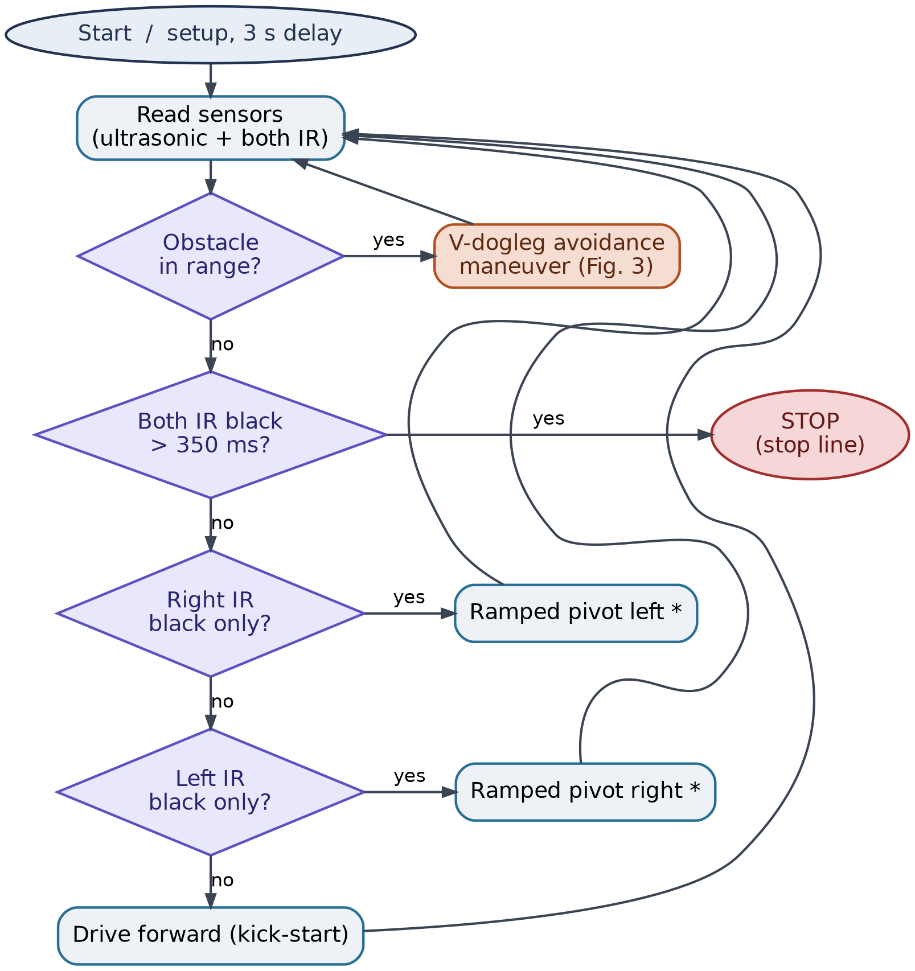
Figure 2. Main control loop (§3.3). Each iteration resolves the highest-priority condition first — obstacle, then stop line, then line following. * The software pivot directions are physically inverted on this chassis; see §3.3.
3.5 Obstacle-avoidance routine
When an obstacle is detected, the robot executes the three-phase V-dogleg maneuver illustrated in Fig. 3. In Phase 1 it pivots about 45° away from the line (to the right) and drives clear of the obstacle. In Phase 2 it travels straight for a fixed duration (passTime ≈ 600 ms), carrying it past the side of the obstacle. In Phase 3 it pivots back toward the line and continues until the right IR sensor detects the line again, at which point control returns to normal line following. The final phase is closed-loop — it does not rely on a pre-set angle but instead watches the IR sensor and stops turning the instant the line is re-acquired — which is what makes the return repeatable across slightly different obstacle positions. A timeout failsafe stops the robot and reports an error if the line is not found within a few seconds, preventing it from circling indefinitely.
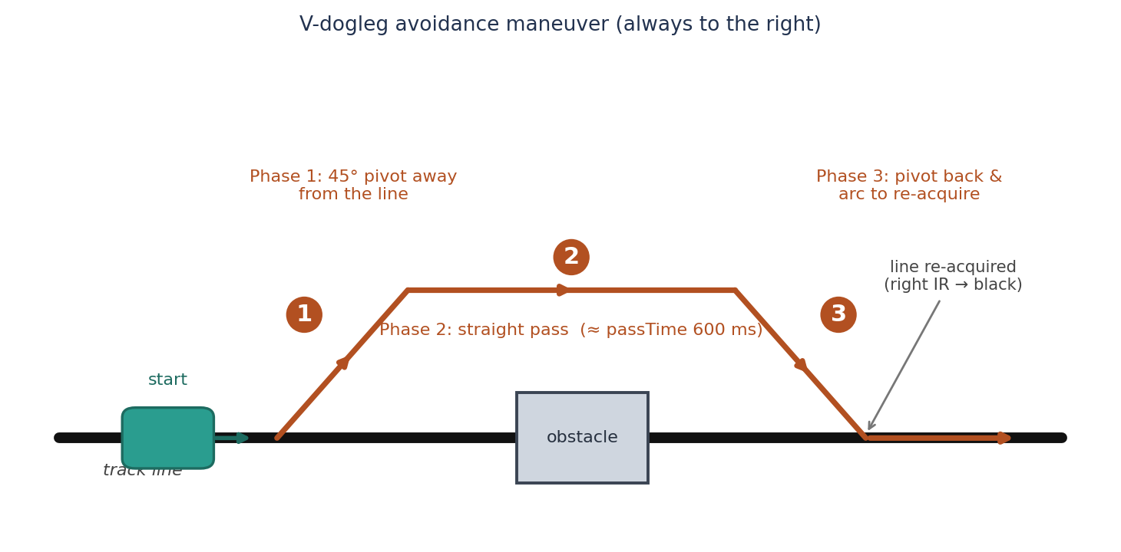
Figure 3. Three-phase V-dogleg obstacle-avoidance maneuver. The return (Phase 3) is closed-loop: the robot stops turning the moment the right IR sensor re-acquires the line.
This V-dogleg strategy was selected after comparing it directly on the floor against two alternatives — a half-circle arc and a rectangular box detour; that comparison is reported in Section 4.
4. Simulation and Testing Results
Methodology. Validation was carried out in two stages: controlled bench tests and full track tests. Because the kit’s real-world behaviour could not be reproduced faithfully in software simulation, these physical tests — rather than a simulator — served as the primary verification environment, with the Arduino’s serial output providing live telemetry of sensor states and control decisions.
Bench testing. A dedicated diagnostic sketch confirmed that each IR sensor switched cleanly between the line and the floor and that both ultrasonic sensors returned plausible distances. The robot was also held in the air to verify motor direction and, importantly, to confirm the steering inversion (that turnLeft() swings the nose to the right) before any track run.
Line following and stop lines. With the final parameters of Table 2, the robot tracked the line reliably through straight and curved sections. The 350 ms double-dark probe distinguished genuine stop lines from ordinary line crossings, so the robot halted dependably at stop lines while ignoring brief intersections.
Obstacle avoidance. Three avoidance strategies were implemented and compared on the physical track. A half-circle arc was geometrically simple, but its open-loop return frequently missed the line. A rectangular box detour was predictable but slow and prone to clipping the obstacle on the turns. The V-dogleg maneuver with closed-loop re-acquisition (§3.5) proved the most repeatable and was adopted as the final design. After avoidance was integrated, the robot initially “shook” when it resumed line following; softening the line-following ramp (to rampMax = 30, rampStep = 8) damped this oscillation and produced a smooth hand-back to tracking.
Table 2. Final tuned control parameters.
Parameter | Value | Role
baseSpeed | 65 PWM | straight-line cruise speed
turnSpeed | 75 PWM | outer-wheel speed during a pivot
kickSpeed / kickTime | 150 PWM / 60 ms | start-up burst to overcome static friction
rampStep / rampMax | 8 / 30 PWM | progressive pivot strength when the line is lost
stop-line probe | 350 ms | double-dark duration confirming a stop line
passTime | 600 ms | straight-pass duration during avoidance
obstacle trigger | ≈ 14 cm | ultrasonic distance that starts avoidance (surface-tuned)
Tuning outcomes. The values in Table 2 emerged from this iterative process. Driving speed was reduced over several iterations (from an initial 160 PWM down to 65) until the robot tracked accurately, and the kick-start and ramp parameters were tuned last to give clean starts and stable cornering. The trigger distance was set on the test surface to roughly 14 cm so that the maneuver began early enough to clear the obstacle without reacting to distant clutter.
5. Challenges Encountered and Solutions
Several substantive problems were encountered and resolved during development.
Motor dead-zone and a misdiagnosed power problem. The most consequential issue was the motor dead-zone described in §3.4. It was initially mistaken for an under-powered battery, and an external voltage regulator and a battery change were briefly considered — both of which would have violated the kit-only rule. Once the project’s matched hardware set was confirmed, the problem was re-framed correctly as motor static friction and solved in software with the kick-start pulse. The lesson generalises: with powerful geared motors, an apparent “won’t start, or moves too fast” symptom is often a torque-at-rest problem rather than a supply problem.
Inverted steering. Early runs turned the wrong way even though the IR sensors read correctly. The cause was the physical motor wiring and orientation, not the sensing. Rather than rewire the chassis, the fix was to swap the turn calls in software and to document the inversion as an intentional characteristic so it would not be inadvertently reversed in a later revision.
A counter-intuitive arc-radius relationship. While tuning the avoidance arc, an initial assumption that narrowing the speed difference between the wheels would tighten the circle proved wrong on the floor: a wider PWM gap between the outer and inner wheels in fact produces a tighter arc. This was corrected empirically, and it directly informed how the avoidance and turning parameters were set.
Avoidance-strategy selection and post-avoidance oscillation. As described in Section 4, the avoidance approach was chosen by physical comparison rather than by analysis, and the residual shaking after a maneuver was eliminated by softening the correction ramp.
A common theme links these challenges: throughout the project, physical testing repeatedly overruled theoretical expectation, which is why the iterative, hardware-in-the-loop methodology of Section 2 was essential.
6. Conclusions and Future Improvements
The project met all of its objectives within the kit-only constraint: the completed robot follows a line reliably, circumnavigates obstacles with a repeatable V-dogleg maneuver, and halts at stop lines, accompanied by source code, flowcharts, and wiring documentation suitable for assessment and public release. The work also showed that a simple reactive controller is sufficient for this class of task, and it produced transferable insight into low-cost geared-motor drivetrains — notably the kick-start needed to overcome static friction and the counter-intuitive arc-radius relationship.
Several improvements would be natural next steps. A proportional or PID controller in place of the bang-bang line follower would give smoother tracking on tight curves; wheel encoders would enable distance-based maneuvers robust to battery sag, replacing the present time-based phases; and adaptive IR thresholding would tolerate changes in lighting and surface reflectivity. Using the ultrasonic sensors to measure an obstacle’s width could also let the avoidance geometry adapt per obstacle rather than following a fixed dogleg. Some of these — notably encoders — would require components beyond the present kit and would depend on the constraints of any follow-on project.
References
[1] Arduino, “Arduino UNO Rev3 — Product Reference,” Arduino Documentation.
[2] STMicroelectronics, “L298 — Dual Full-Bridge Driver,” Datasheet.
[3] “HC-SR04 Ultrasonic Ranging Module,” Component Datasheet.
[4] R. Siegwart, I. R. Nourbakhsh, and D. Scaramuzza, Introduction to Autonomous Mobile Robots, 2nd ed. Cambridge, MA: MIT Press, 2011.

